# PROGRAM 1 Date:21/12/2021

**AIM:** Develop Android application to implement button click using Toast.

**PROGRAM CODE:**

## activity.xml

<?xml version="1.0" encoding="utf-8"?>

<androidx.constraintlayout.widget.ConstraintLayoutxmlns:android="http://schemas.android.c om/apk/res/android"

xmlns:app="http://schemas.android.com/apk/res-auto" xmlns:tools="http://schemas.android.com/tools" android:layout_width="match_parent" android:layout_height="match_parent" tools:context=".MainActivity">

<Button

android:layout_width="wrap_content" android:layout_height="wrap_content" android:id="@+id/b" android:textColor="#000000" android:textSize="30sp" android:background="#ffffff" android:text="button"

/>

</androidx.constraintlayout.widget.ConstraintLayout> **mainactivity.java**

package com.example.myApplication02; import androidx.appcompat.app.AppCompatActivity; import android.os.Bundle; import android.view.View; import android.widget.Button; import android.widget.Toast;

public class MainActivity extends AppCompatActivity {

@Override

protected void onCreate(Bundle savedInstanceState) { super.onCreate(savedInstanceState); setContentView(R.layout.activity_main);

Button b=findViewById(R.id.b);

b.setOnClickListener(new View.OnClickListener() { @Override

public void onClick(View view) {

Toast.makeText(getApplicationContext(),"button clicked",Toast.LENGTH_LONG).show();

} });

} }

**RESULT:** Program compiled successfully and output verified.

**OUTPUT:**

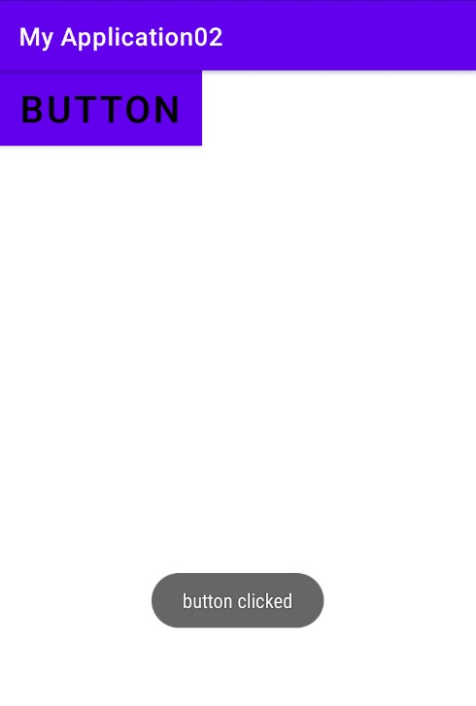

# PROGRAM 2 Date:5/1/2022

**AIM:** Develop interactive Android application using button.

**PROGRAM CODE:**

## activity.xml

*<?*xml version="1.0" encoding="utf-8"*?>*

<LinearLayout xmlns:android="http://schemas.android.com/apk/res/android" xmlns:app="http://schemas.android.com/apk/res-auto" xmlns:tools="http://schemas.android.com/tools" android:orientation="horizontal" android:layout_width="match_parent" android:layout_height="match_parent" tools:context=".MainActivity"

android:gravity="center">

<Button

android:id="@+id/bt1" android:layout_width="wrap_content" android:layout_height="wrap_content"

android:text="click here" />

<TextView

android:id="@+id/tv1" android:layout_width="wrap_content" android:layout_height="wrap_content"

android:text="0"

android:textSize="25sp" />

</LinearLayout>

**mainactivity.java**

package com.example.myapplication;

import androidx.appcompat.app.AppCompatActivity; import android.app.*; import android.os.*; import android.widget.*; import android.os.Bundle; import android.view.*;

import android.view.View.*;

public class MainActivity extends AppCompatActivity { private Button bt1; private TextView tv1; private int db;

@Override

public void onCreate(Bundle savedInstanceState) {

super.onCreate(savedInstanceState); setContentView(R.layout.*activity_main*); bt1=findViewById(R.id.*bt1*); tv1=findViewById(R.id.*tv1*);

bt1.setOnClickListener(new View.OnClickListener(){

@Override

public void onClick(View view) { db++;

tv1.setText(String.*valueOf*(db));

}

});

} }

**RESULT:** Program compiled successfully and output verified.

**OUTPUT:**

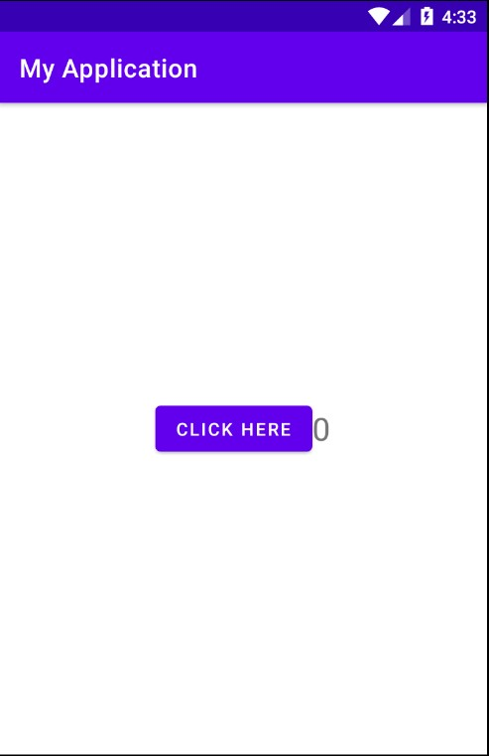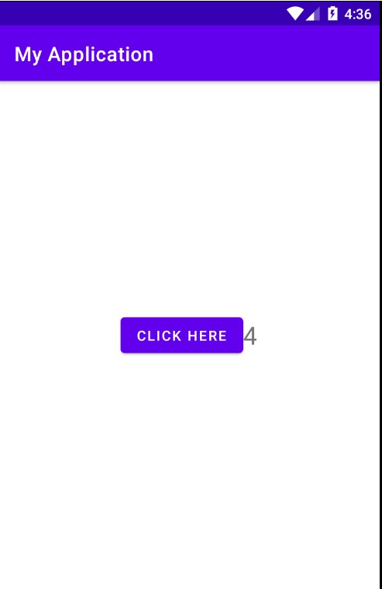

# PROGRAM 3 Date:12/1/2022

**AIM:** Develop interactive Android application using button to change styles.

**PROGRAM CODE:**

## activity.xml

*<?*xml version="1.0" encoding="utf-8"*?>*

<LinearLayout xmlns:android="http://schemas.android.com/apk/res/android" xmlns:app="http://schemas.android.com/apk/res-auto" xmlns:tools="http://schemas.android.com/tools" android:layout_width="match_parent" android:layout_height="match_parent" android:orientation="vertical"

tools:context=".MainActivity">

<TextView android:id="@+id/tv" android:layout_width="319dp" android:layout_height="wrap_content" android:text="SNGIST"

android:textColor="@android:color/black" android:textSize="24sp" android:textStyle="bold"/>

<Button

android:id="@+id/b1" android:layout_width="match_parent" android:layout_height="wrap_content" android:text="CHANGE FONT SIZE"

android:textSize="24sp"/>

<Button

android:id="@+id/b2" android:layout_width="match_parent" android:layout_height="wrap_content"

android:text="CHANGE FONT COLOR" android:textSize="24sp"/>

</LinearLayout>

## mainactivity.java

package com.example.myapplication4;

import androidx.appcompat.app.AppCompatActivity;

import android.graphics.Color; import android.graphics.fonts.Font; import android.os.Bundle; import android.view.View; import android.widget.Button; import android.widget.TextView;

public class MainActivity extends AppCompatActivity { int ch=1; float font=40; @Override

protected void onCreate(Bundle savedInstanceState) { super.onCreate(savedInstanceState); setContentView(R.layout.*activity_main*); TextView t=findViewById(R.id.*tv*); Button b1=findViewById(R.id.*b1*);

b1.setOnClickListener(new View.OnClickListener() {

@Override

public void onClick(View view) { t.setTextSize(font); font=font+5;

if (font==50) font=30;

}

});

Button b2=findViewById(R.id.*b2*);

b2.setOnClickListener(new View.OnClickListener() {

@Override

public void onClick(View view) {

switch (ch) { case 1:

t.setTextColor(Color.*RED*);

break; case 2:

t.setTextColor(Color.*GREEN*);

break; case 3:

t.setTextColor(Color.*YELLOW*); break; case 4:

t.setTextColor(Color.*BLUE*);

break; case 5:

t.setTextColor(Color.*GRAY*);

break;

} ch++;

if (ch==6) ch=1;

}

});

}

}

**RESULT:** Program compiled successfully and output verified.

**OUTPUT:**

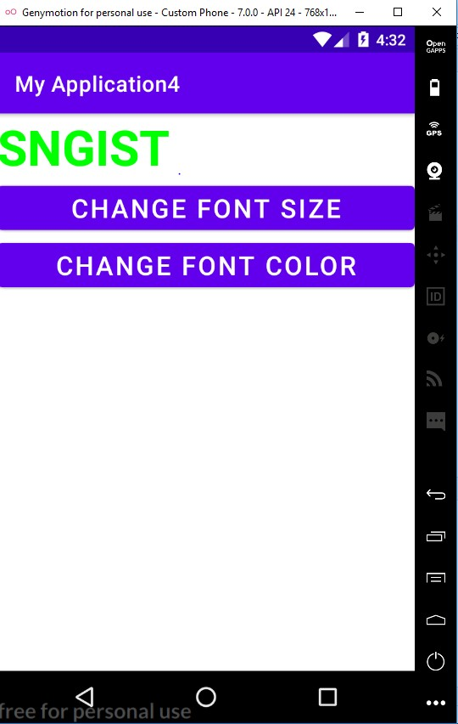

# PROGRAM 4 Date:12/1/2022

**AIM:** Design a Login Form with username and password using LinearLayout and toast valid credentials.

**PROGRAM CODE:**

## activity.xml

*<?*xml version="1.0" encoding="utf-8"*?>*

<LinearLayout xmlns:android="http://schemas.android.com/apk/res/android" xmlns:app="http://schemas.android.com/apk/res-auto" xmlns:tools="http://schemas.android.com/tools" android:layout_width="match_parent" android:layout_height="match_parent" android:orientation="vertical" tools:context=".MainActivity">

<TextView

android:layout_width="wrap_content" android:layout_height="wrap_content" android:text="username"/>

<EditText

android:id="@+id/e2" android:layout_width="190dp" android:layout_height="wrap_content" android:ems="10"

android:inputType="textPersonName"

android:text="" /> <TextView android:layout_width="wrap_content" android:layout_height="wrap_content" android:text="password"/>

<EditText

android:id="@+id/e1" android:layout_width="64dp" android:layout_height="wrap_content" android:inputType="textPassword" />

<Button

android:id="@+id/b1" android:layout_width="match_parent" android:layout_height="wrap_content" android:text="SUBMIT"/>

</LinearLayout>

## mainactivity.java

package com.example.myapplication5; import androidx.appcompat.app.AppCompatActivity;

import android.os.Bundle; import android.view.View; import android.widget.Button; import android.widget.Toast;

public class MainActivity extends AppCompatActivity {

Button b1; @Override

protected void onCreate(Bundle savedInstanceState) { super.onCreate(savedInstanceState); setContentView(R.layout.*activity_main*); b1=findViewById(R.id.*b1*);

b1.setOnClickListener(new View.OnClickListener() {

@Override

public void onClick(View view) {

Toast.*makeText*(getApplicationContext(),"SUCCESSFULLY

LOGIN",Toast.*LENGTH_LONG*).show(); }

});

}

}

**RESULT:** Program compiled successfully and output verified.

**OUTPUT:**

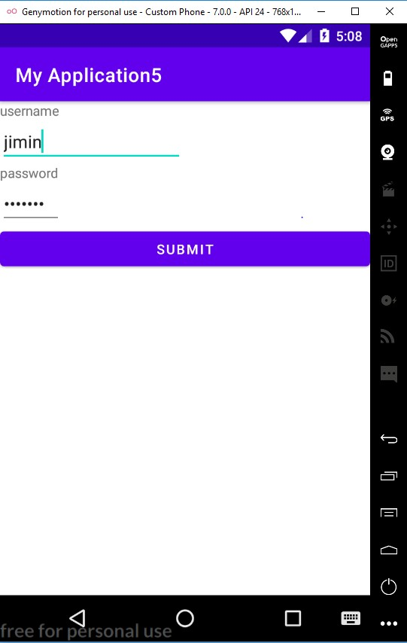

# PROGRAM 5 Date:18/1/2022

**AIM:** Implementing basic arithmetic operations of a simple calculator.

**PROGRAM CODE:**

## activity.xml

*<?*xml version="1.0" encoding="utf-8"*?>*

<LinearLayout xmlns:android="http://schemas.android.com/apk/res/android" xmlns:app="http://schemas.android.com/apk/res-auto" xmlns:tools="http://schemas.android.com/tools" android:orientation="vertical" android:layout_width="match_parent" android:layout_height="match_parent"

tools:context=".MainActivity">

<TextView android:layout_width="wrap_content" android:layout_height="wrap_content" android:text="Enter 1st nmbr" />

<EditText

android:id="@+id/et1" android:layout_width="wrap_content"

android:layout_height="wrap_content" />

<TextView android:layout_width="wrap_content" android:layout_height="wrap_content" android:text="Enter 2st nmbr" />

<EditText

android:id="@+id/et2" android:layout_width="wrap_content"

android:layout_height="wrap_content" />

<LinearLayout

android:layout_width="wrap_content"

android:layout_height="wrap_content">

<Button android:layout_width="wrap_content" android:layout_height="wrap_content" android:id="@+id/b1"

android:text="ADD"/>

<Button

android:layout_width="wrap_content" android:layout_height="wrap_content" android:id="@+id/b2" android:text="SUB"/>

<Button android:layout_width="wrap_content" android:layout_height="wrap_content" android:id="@+id/b3"

android:text="MUL"/>

<Button android:layout_width="wrap_content" android:layout_height="wrap_content" android:id="@+id/b4" android:text="DIV"/>

</LinearLayout> <TextView android:id="@+id/tv1" android:layout_width="wrap_content"

android:layout_height="wrap_content"/>

</LinearLayout>

## mainactivity.java

package com.example.myapplication6;

import androidx.appcompat.app.AppCompatActivity;

import android.os.Bundle; import android.view.View; import android.widget.Button; import android.widget.EditText;

import android.widget.TextView;

public class MainActivity extends AppCompatActivity {

Button b,bb,bc,bd;

EditText et1,et2;

TextView tv1;

@Override

protected void onCreate(Bundle savedInstanceState) { super.onCreate(savedInstanceState); setContentView(R.layout.*activity_main*); b=findViewById(R.id.*b1*); bb=findViewById(R.id.*b2*); bc=findViewById(R.id.*b3*); bd=findViewById(R.id.*b4*); et1=findViewById(R.id.*et1*); et2=findViewById(R.id.*et2*); tv1=findViewById(R.id.*tv1*);

b.setOnClickListener(new View.OnClickListener() { @Override

public void onClick(View view) {

Double a1= Double.*parseDouble*(et1.getText().toString());

Double a2= Double.*parseDouble*(et2.getText().toString()); Double r=a1+a2;

tv1.setText("Result is: " +String.*valueOf*(r));

}

});

bb.setOnClickListener(new View.OnClickListener() {

@Override

public void onClick(View view) {

Double a1= Double.*parseDouble*(et1.getText().toString());

Double a2= Double.*parseDouble*(et2.getText().toString());

Double r=a1-a2;

tv1.setText("Result is: " +String.*valueOf*(r));

}

});

bc.setOnClickListener(new View.OnClickListener() {

@Override

public void onClick(View view) {

Double a1= Double.*parseDouble*(et1.getText().toString());

Double a2= Double.*parseDouble*(et2.getText().toString());

Double r=a1*a2;

tv1.setText("Result is: " +String.*valueOf*(r));

}

});

bd.setOnClickListener(new View.OnClickListener() {

@Override

public void onClick(View view) {

Double a1= Double.*parseDouble*(et1.getText().toString()); Double a2= Double.*parseDouble*(et2.getText().toString());

Double r=a1/a2;

tv1.setText("Result is: " +String.*valueOf*(r));

}

});

}

}

**RESULT:** Program compiled successfully and output verified.

**OUTPUT:**

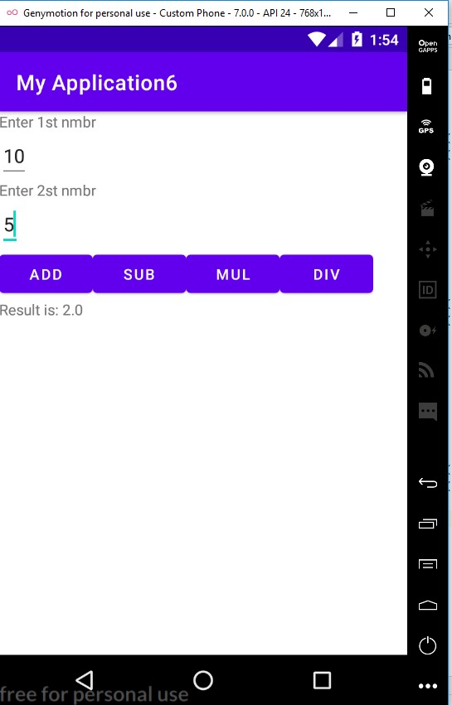

# PROGRAM 6 Date:22/1/2022

**AIM:** Write a program to implement explicit intent.

**PROGRAM CODE:**

## activity.xml

*<?*xml version="1.0" encoding="utf-8"*?>*

<LinearLayout xmlns:android="http://schemas.android.com/apk/res/android" xmlns:app="http://schemas.android.com/apk/res-auto" xmlns:tools="http://schemas.android.com/tools" android:layout_width="match_parent" android:layout_height="match_parent" tools:context=".MainActivity">

<Button

android:id="@+id/b1" android:layout_width="wrap_content" android:layout_height="wrap_content"

android:text="Click"/>

</LinearLayout>

## mainActivity.java

package com.example.myapplication;

import androidx.appcompat.app.AppCompatActivity;

import android.content.Intent; import android.os.Bundle; import android.view.View; import android.widget.Button;

import android.widget.Toast;

public class MainActivity extends AppCompatActivity {

@Override

protected void onCreate(Bundle savedInstanceState) { super.onCreate(savedInstanceState); setContentView(R.layout.*activity_main*);

Button b=findViewById(R.id.*b1*);

b.setOnClickListener(new View.OnClickListener() {

@Override

public void onClick(View view) { Toast.*makeText*(getApplicationContext(),"clicked",Toast.*LENGTH_LONG*).show();

Intent i = new Intent(MainActivity.this,Activity1.class); startActivity(i);

}

});

}

## } activity1.xml

*<?*xml version="1.0" encoding="utf-8"*?>*

<LinearLayout xmlns:android="http://schemas.android.com/apk/res/android" xmlns:app="http://schemas.android.com/apk/res-auto" xmlns:tools="http://schemas.android.com/tools" android:layout_width="match_parent" android:layout_height="match_parent"

tools:context=".Activity1">

<TextView android:layout_width="wrap_content" android:layout_height="wrap_content" android:text="Welcome"/>

</LinearLayout>

## activity1.java

package com.example.intent;

import androidx.appcompat.app.AppCompatActivity;

import android.os.Bundle;

public class Activity1 extends AppCompatActivity {

@Override

protected void onCreate(Bundle savedInstanceState) { super.onCreate(savedInstanceState);

setContentView(R.layout.activity_1);

}

}

**RESULT:** Program compiled successfully and output verified.

**OUTPUT:**

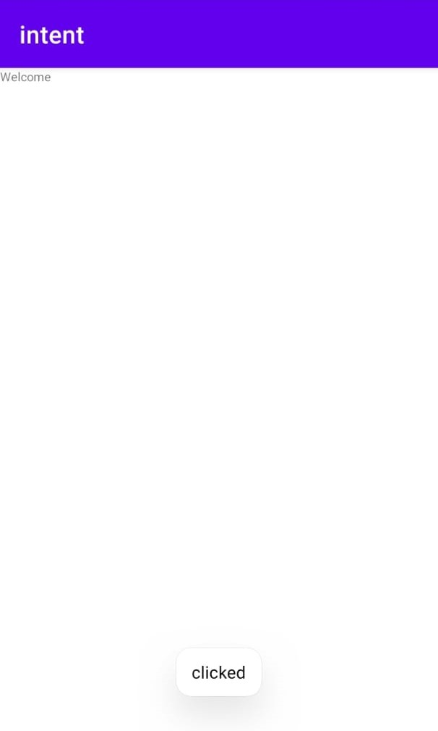

# PROGRAM 7 Date:25/1/2022

**AIM:** Write a program to implement implicit intent.

**PROGRAM CODE:**

## activity_main.xml

<?xml version="1.0" encoding="utf-8"?>

<LinearLayout xmlns:android="http://schemas.android.com/apk/res/android" xmlns:app="http://schemas.android.com/apk/res-auto" xmlns:tools="http://schemas.android.com/tools" android:layout_width="match_parent" android:layout_height="match_parent" tools:context=".MainActivity" android:orientation="vertical">

<EditText

android:id="@+id/e1"

android:layout_width="wrap_content" android:layout_height="wrap_content" android:text="http://www.google.com"/>

<Button

android:id="@+id/b1"

android:layout_width="wrap_content" android:layout_height="wrap_content" android:text="VISIT" />

</LinearLayout>

## mainActivity.java

package com.example.myapplication;

import androidx.appcompat.app.AppCompatActivity;

import android.content.Intent; import android.net.Uri; import android.os.Bundle; import android.view.View; import android.widget.Button; import android.widget.EditText;

public class MainActivity extends AppCompatActivity {

@Override

protected void onCreate(Bundle savedInstanceState) { super.onCreate(savedInstanceState); setContentView(R.layout.activity_main); Button b = findViewById(R.id.b1); EditText et = findViewById(R.id.e1);

b.setOnClickListener(new View.OnClickListener() { @Override

public void onClick(View view) {

String url = et.getText().toString();

Intent i = new Intent(Intent.ACTION_VIEW, Uri.parse(url)); startActivity(i);

}

});

}

**RESULT:** Program compiled successfully and output verified.

**OUTPUT:**

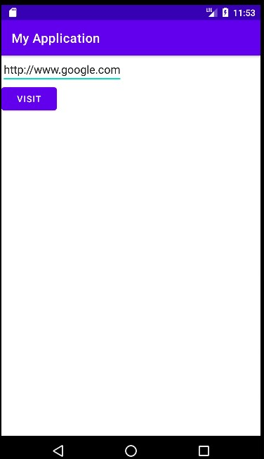

# PROGRAM 8 Date:1/2/2022

**AIM:** Write a program to design a Login and Registration form using LinearLayout.

**PROGRAM CODE:**

## activity.xml

*<?*xml version="1.0" encoding="utf-8"*?>*

<LinearLayout xmlns:android="http://schemas.android.com/apk/res/android" android:layout_width="match_parent" android:layout_height="match_parent" android:gravity="center">

<TextView

android:text="Welcome" android:layout_width="wrap_content"

android:layout_height="wrap_content"/>

</LinearLayout>

## Login.xml

*<?*xml version="1.0" encoding="utf-8"*?>*

<LinearLayout xmlns:android="http://schemas.android.com/apk/res/android" xmlns:app="http://schemas.android.com/apk/res-auto" xmlns:tools="http://schemas.android.com/tools" android:layout_width="fill_parent" android:layout_height="fill_parent" tools:context=".MainActivity" android:orientation="vertical"

android:gravity="center">

<TextView

android:text="LOGIN PAGE" android:layout_width="wrap_content" android:layout_height="wrap_content"

android:textStyle="bold"

android:textSize="40dp"/>

<TextView

android:text="Username" android:layout_width="wrap_content"

android:layout_height="wrap_content"/>

<EditText

android:layout_width="wrap_content"

android:layout_height="wrap_content"/>

<TextView

android:text="Password"

android:layout_width="wrap_content"

android:layout_height="wrap_content"/>

<EditText android:inputType="textPassword" android:layout_width="wrap_content"

android:layout_height="wrap_content"/>

<Button android:text="Login" android:layout_width="wrap_content" android:layout_height="wrap_content" android:onClick="well"/>

<Button

android:text="Sign up" android:layout_width="wrap_content" android:layout_height="wrap_content" android:onClick="reg"/>

</LinearLayout>

## Registeration.xml

*<?*xml version="1.0" encoding="utf-8"*?>*

<LinearLayout xmlns:android="http://schemas.android.com/apk/res/android" android:layout_width="fill_parent" android:layout_height="fill_parent"

android:orientation="vertical">

<TextView android:text="REGISTRATION" android:layout_width="wrap_content"

android:layout_height="wrap_content"/>

<TextView android:text="Name"

android:layout_width="wrap_content"

android:layout_height="wrap_content"/>

<EditText android:layout_width="wrap_content"

android:layout_height="wrap_content"/>

<TextView android:text="DOB" android:layout_width="wrap_content" android:layout_height="wrap_content"/> <CalendarView android:layout_width="wrap_content"

android:layout_height="wrap_content"/>

<TextView android:text="Gender" android:layout_width="wrap_content"

android:layout_height="wrap_content"/>

<RadioGroup android:layout_width="wrap_content"

android:layout_height="wrap_content">

<RadioButton android:layout_width="wrap_content" android:layout_height="wrap_content" android:text="Male"/>

<RadioButton android:layout_width="wrap_content" android:layout_height="wrap_content" android:text="Female"/>

</RadioGroup>

<Button android:text="Register" android:layout_width="wrap_content" android:layout_height="wrap_content" android:onClick="log"/>

</LinearLayout>

## mainactivity.java

package com.example.myapplication;

import androidx.appcompat.app.AppCompatActivity;

import android.os.Bundle; import android.view.View; public class MainActivity extends AppCompatActivity {

@Override

protected void onCreate(Bundle savedInstanceState)

{

super.onCreate(savedInstanceState);

setContentView(R.layout.*login*);

}

public void well(View v){ setContentView(R.layout.*activity_main*); }

public void reg(View v){

setContentView(R.layout.*registeration*);

}

public void log(View v){

setContentView(R.layout.*login*);

}

}

**RESULT:** Program compiled successfully and output verified.

**OUTPUT:**

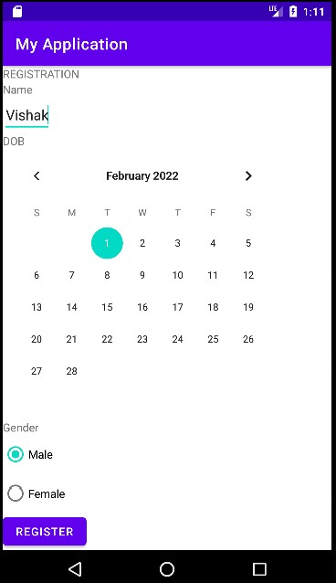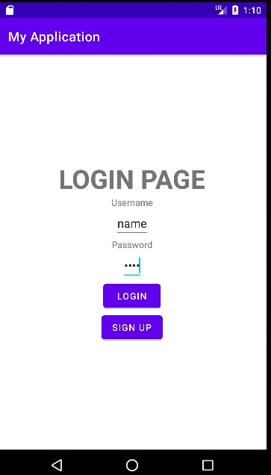

**9 Date:2/2/2022**

Write a program to draw a line between origin and the point where you touch.

**PROGRAM CODE:**

mainactivity.java

package com.example.student.drawline; import android.content.Context; import android.graphics.Canvas; import android.graphics.Color; import android.graphics.Paint;

import android.support.v7.app.AppCompatActivity; import android.os.Bundle; import android.util.AttributeSet; import android.view.MotionEvent;

import android.view.View;

public class MainActivity extends AppCompatActivity {

@Override

protected void onCreate(Bundle savedInstanceState) { super.onCreate(savedInstanceState);

setContentView(new myView(this));

}

public class myView extends View { public myView(Context context) {

super(context);

}

float x1, x2, y1, y2; @Override protected void onDraw(Canvas canvas) {

super.onDraw(canvas); Paint paint = new Paint(0); paint.setColor(Color.*GREEN*); paint.setStrokeWidth(20);

canvas.drawLine(x1, y1, x2, y2, paint);

}

public boolean onTouchEvent(MotionEvent event) { x1 = 0; y1 = 0; x2 = event.getX(); y2 = event.getY();

this.invalidate();

return super.onTouchEvent(event);

}

}

}

**RESULT:** Program compiled successfully and output verified.

**OUTPUT:**

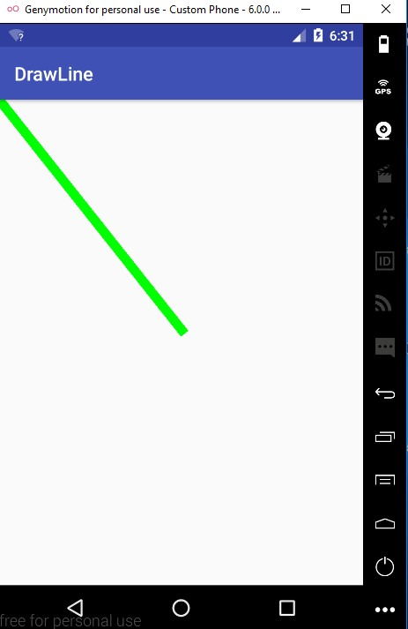

**10 Date:2/2/2022**

Write a program to design draw shapes

**PROGRAM CODE:**

## mainactivity.java

package com.example.student.drawingshape;

import android.content.Context; import android.graphics.Canvas; import android.graphics.Color; import android.graphics.Paint;

import android.support.v7.app.AppCompatActivity; import android.os.Bundle;

import android.view.View;

public class MainActivity extends AppCompatActivity {

@Override

protected void onCreate(Bundle savedInstanceState) { super.onCreate(savedInstanceState);

setContentView(new myview(this));

}

private class myview extends View

{

public myview(Context context) {

super(context);

}

@Override

protected void onDraw(Canvas canvas) {

super.onDraw(canvas); Paint paint = new Paint(); paint.setTextSize(40); paint.setColor(Color.*GREEN*); canvas.drawText("Circle", 55, 30, paint); paint.setColor(Color.*RED*); canvas.drawCircle(100, 150, 100, paint); paint.setColor(Color.*GREEN*);

canvas.drawText("Rectangle", 255, 30, paint); paint.setColor(Color.*YELLOW*); canvas.drawRect(250, 50, 400, 350, paint); paint.setColor(Color.*GREEN*); canvas.drawText("Square", 55, 430, paint); paint.setColor(Color.*BLUE*);

canvas.drawRect(50, 450, 150, 550, paint); paint.setColor(Color.*GREEN*); canvas.drawText("Line", 255, 430, paint); paint.setColor(Color.*CYAN*); canvas.drawLine(250, 500, 350, 500, paint);

}

}

}

**RESULT:** Program compiled successfully and output verified.

**OUTPUT:**

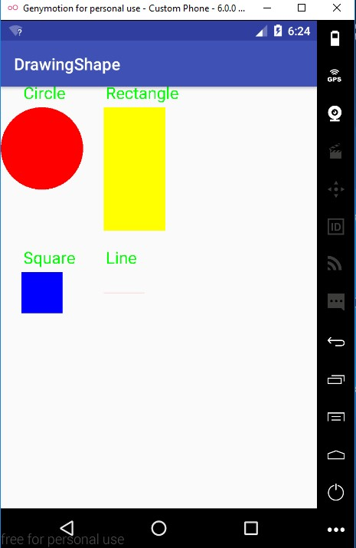

**11 Date:9/2/2022**

Implement Simple Login application with number of attempts.

**PROGRAM CODE:**

## activity xml

*<?*xml version="1.0" encoding="utf-8"*?>*

<LinearLayout xmlns:android="http://schemas.android.com/apk/res/android" xmlns:app="http://schemas.android.com/apk/res-auto" xmlns:tools="http://schemas.android.com/tools" android:orientation="vertical" android:layout_width="match_parent" android:layout_height="match_parent" tools:context=".MainActivity">

<TextView

android:text="USERNAME" android:layout_width="wrap_content" android:layout_height="wrap_content"/>

<EditText

android:id="@+id/et1" android:layout_width="wrap_content" android:layout_height="wrap_content"/>

<TextView

android:text="PASSWORD" android:layout_width="wrap_content" android:layout_height="wrap_content"/>

<EditText

android:id="@+id/et2" android:inputType="textPassword" android:layout_width="wrap_content" android:layout_height="wrap_content"/>

<Button

android:id="@+id/b1" android:text="Login"

android:layout_width="wrap_content" android:layout_height="wrap_content"/>

<TextView

android:id="@+id/tv1" android:layout_width="wrap_content" android:layout_height="wrap_content"/>

</LinearLayout>

## activitysecond.xml

*<?*xml version="1.0" encoding="utf-8"*?>*

<LinearLayout xmlns:android="http://schemas.android.com/apk/res/android" xmlns:app="http://schemas.android.com/apk/res-auto" xmlns:tools="http://schemas.android.com/tools" android:layout_width="match_parent" android:layout_height="match_parent"

tools:context=".SecondActivity">

<TextView

android:text="Welcome to Second Activity" android:layout_width="wrap_content" android:layout_height="wrap_content"/>

</LinearLayout>

## Mainactivity.java

import androidx.appcompat.app.AppCompatActivity;

import android.content.Intent; import android.os.Bundle; import android.view.View; import android.widget.Button; import android.widget.EditText;

import android.widget.TextView;

public class MainActivity extends AppCompatActivity {

EditText et1,et2;

Button b1; TextView tv1;

int c=5;

protected void onCreate(Bundle savedInstanceState) { super.onCreate(savedInstanceState); setContentView(R.layout.*activity_main*); et1=findViewById(R.id.*et1*); et2=findViewById(R.id.*et2*); b1=findViewById(R.id.*b1*); tv1=findViewById(R.id.*tv1*);

tv1.setText("Number of attempts remaining: 5"); b1.setOnClickListener(new View.OnClickListener() {

@Override

public void onClick(View view) {

validate(et1.getText().toString(),et2.getText().toString());

}

});

}

private void validate(String un,String pw){ if((un.equals("Admin")) && (pw.equals("1234"))){

Intent i=new Intent(MainActivity.this,SecondActivity.class); startActivity(i);

} else { c--;

tv1.setText("Number of attempts remaining "+ String.*valueOf*(c)); if(c==0){

b1.setEnabled(false);

}

}

}

}

## Secondactivity.java

package com.example.myapp3;

import androidx.appcompat.app.AppCompatActivity; import android.os.Bundle;

public class SecondActivity extends AppCompatActivity {

@Override

protected void onCreate(Bundle savedInstanceState) { super.onCreate(savedInstanceState);

setContentView(R.layout.*activity_second*);

}

}

**RESULT:** Program compiled successfully and output verified.

**OUTPUT:**

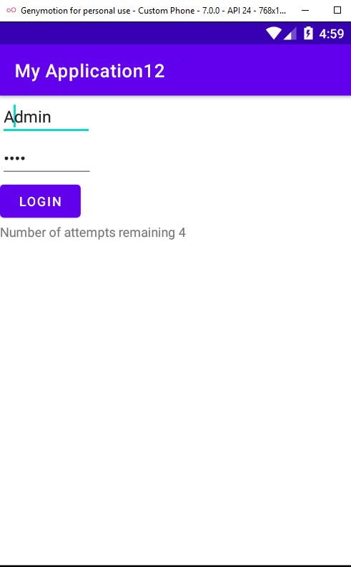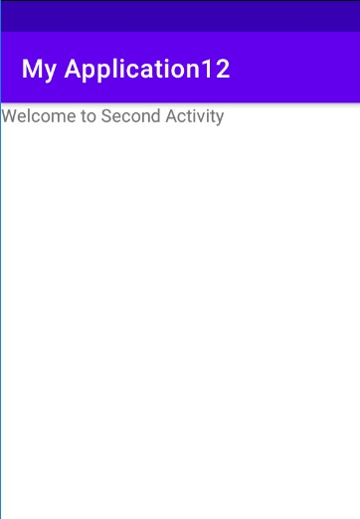

**12 Date:9/2/2022**

Implement and perform exception handling

**PROGRAM CODE:**

## activity xml

*<?*xml version="1.0" encoding="utf-8"*?>*

<RelativeLayout xmlns:android="http://schemas.android.com/apk/res/android" xmlns:app="http://schemas.android.com/apk/res-auto" xmlns:tools="http://schemas.android.com/tools" android:layout_width="match_parent" android:layout_height="match_parent"

tools:context=".MainActivity">

<TextView android:layout_width="wrap_content" android:layout_height="wrap_content" android:id="@+id/tv1" />

</RelativeLayout>

## Mainactivity.java

package com.example.myapplication13;

import androidx.appcompat.app.AppCompatActivity;

import android.os.Bundle; import android.widget.TextView;

import android.widget.Toast;

public class MainActivity extends AppCompatActivity {

TextView tv1; @Override protected void onCreate(Bundle savedInstanceState) { super.onCreate(savedInstanceState);

setContentView(R.layout.*activity_main*); try {

tv1.setText("WELCOME");

}

catch (Exception e)

{

Toast.*makeText*( this,e.getMessage(),Toast.*LENGTH_LONG*).show();

}

}

}

**RESULT:** Program compiled successfully and output verified.

**OUTPUT:**

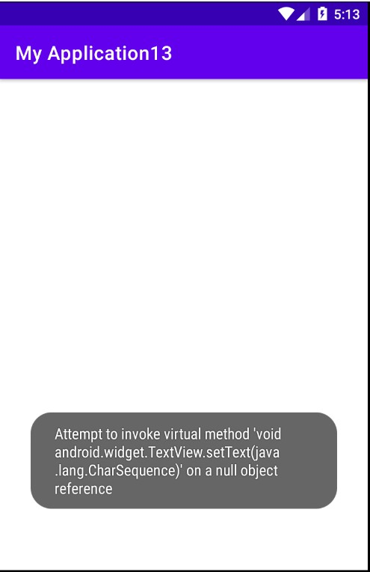

**13 Date:10/2/2022**

Implement Options Menu to navigate to activities.

**PROGRAM CODE:**

## menu.xml

<?xml version="1.0" encoding="utf-8"?>

<menu xmlns:android="http://schemas.android.com/apk/res/android">

<item android:id="@+id/item1" android:title="FILE"/> <item android:id="@+id/item2" android:title="EDIT">

<menu>

<item android:id="@+id/sitem1" android:title="CUT"/> <item android:id="@+id/sitem2" android:title="COPY"/> <item android:id="@+id/sitem3" android:title="PASTE"/>

</menu>

</item>

<item android:id="@+id/item3"

android:title="VIEW"/>

</menu>

## mainacativity.java

package com.example.myapplication14**;**

import androidx.annotation.NonNull;

import androidx.appcompat.app.AppCompatActivity;

import android.os.Bundle; import android.view.Menu; import android.view.MenuItem;

import android.widget.Toast;

public class MainActivity extends AppCompatActivity {

@Override

protected void onCreate(Bundle savedInstanceState) { super.onCreate(savedInstanceState);

setContentView(R.layout.activity_main);

}

@Override

public boolean onCreateOptionsMenu(Menu menu) {

getMenuInflater().inflate(R.menu.menu,menu); return true;

}

@Override

public boolean onOptionsItemSelected(@NonNull MenuItem item) { switch (item.getItemId()){ case R.id.item1:

Toast.makeText(getApplicationContext(),"File Selected",Toast.LENGTH_LONG).show(); case R.id.item2:

Toast.makeText(getApplicationContext(),"Edit Selected",Toast.LENGTH_LONG).show(); case R.id.item3:

Toast.makeText(getApplicationContext(),"View

Selected",Toast.LENGTH_LONG).show();

default:return super.onOptionsItemSelected(item);

}

}

}

**RESULT:** Program compiled successfully and output verified.

**OUTPUT:**

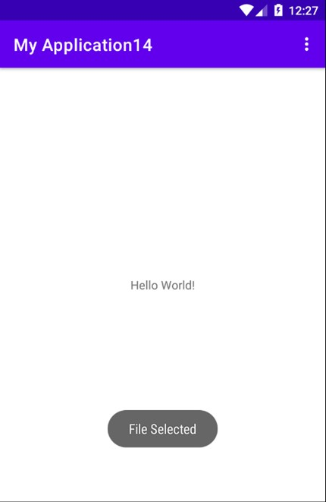

**14 Date:15/2/2022**

Develop an application that uses ArrayAdapter with ListView.

**PROGRAM CODE:**

## activity_main.xml

*<?*xml version="1.0" encoding="utf-8"*?>*

<RelativeLayout xmlns:android="http://schemas.android.com/apk/res/android" xmlns:app="http://schemas.android.com/apk/res-auto" xmlns:tools="http://schemas.android.com/tools" android:layout_width="match_parent" android:layout_height="match_parent"

tools:context=".MainActivity">

<ListView

android:id="@+id/lv1" android:layout_width="match_parent"

android:layout_height="match_parent"

/>

## </RelativeLayout> Mainactivity.java

package com.example.myapplication15;

import androidx.appcompat.app.AppCompatActivity;

import android.os.Bundle; import android.view.View; import android.widget.AdapterView; import android.widget.ArrayAdapter; import android.widget.ListView;

import android.widget.Toast;

public class MainActivity extends AppCompatActivity {

ListView l;

String [] p={"Rajendra Prasd(1884-1963)","S Radhakrishnan(1888- 1993)","Zakir Husain (1894-1980)"}; @Override

protected void onCreate(Bundle savedInstanceState) { super.onCreate(savedInstanceState); setContentView(R.layout.*activity_main*); l=(ListView)findViewById(R.id.*lv1*);

ArrayAdapter <String> adapter= new

ArrayAdapter<String>(this,android.R.layout.*simple_list_item_1*,p); l.setAdapter(adapter);

l.setOnItemClickListener(new AdapterView.OnItemClickListener() { @Override

public void onItemClick(AdapterView<?> adapterView, View view, int i, long l) { Toast.*makeText*(getBaseContext(),p[i],Toast.*LENGTH_LONG*).show();

}

});

}

}

**RESULT:** Program compiled successfully and output verified.

**OUTPUT:**

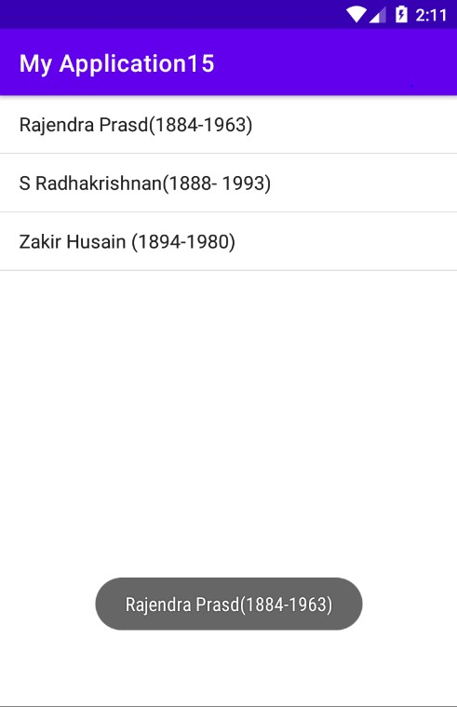

**15 Date:17/2/2022**

**AIM:** Create database using SQLite and perform INSERT, SELECT, UPDATE and DELETE on SQLite database.

**PROGRAM CODE:**

## activity_main.xml

*<?*xml version="1.0" encoding="utf-8"*?>*

<RelativeLayout xmlns:android="http://schemas.android.com/apk/res/android" xmlns:app="http://schemas.android.com/apk/res-auto" xmlns:tools="http://schemas.android.com/tools" android:layout_width="match_parent" android:layout_height="match_parent" android:padding="10dp"

tools:context=".MainActivity">

<TextView android:layout_width="match_parent" android:layout_height="wrap_content" android:text="Please enter the details below:" android:textSize="24dp"

android:id="@+id/texttitle"

/>

<EditText

android:id="@+id/et1" android:layout_width="match_parent" android:layout_height="wrap_content" android:hint="Name" android:textSize="24dp" android:inputType="textPersonName"

android:layout_below="@+id/texttitle"/>

<EditText

android:id="@+id/et2"

android:layout_width="match_parent" android:layout_height="wrap_content" android:hint="Contact" android:textSize="24dp" android:inputType="number" android:layout_below="@+id/et1"/>

<EditText

android:id="@+id/et3"

android:layout_width="match_parent" android:layout_height="wrap_content" android:hint="DOB" android:textSize="24dp" android:inputType="number" android:layout_below="@+id/et2"/> <Button

android:id="@+id/Insert" android:layout_width="match_parent" android:layout_height="wrap_content" android:textSize="24dp" android:text="Insert New Data" android:layout_below="@+id/et3"/>

<Button

android:id="@+id/Update" android:layout_width="match_parent" android:layout_height="wrap_content" android:textSize="24dp" android:text="Update Data"

android:layout_below="@+id/Insert"/>

<Button

android:id="@+id/Delete" android:layout_width="match_parent" android:layout_height="wrap_content" android:textSize="24dp" android:text="Delete Data"

android:layout_below="@+id/Update"/>

<Button

android:id="@+id/View" android:layout_width="match_parent" android:layout_height="wrap_content" android:textSize="24dp" android:text="View Data"

android:layout_below="@+id/Delete"/>

</RelativeLayout>

## DBHelper.java

import android.content.ContentValues; import android.content.Context; import android.database.Cursor;

import android.database.sqlite.SQLiteDatabase;

import android.database.sqlite.SQLiteOpenHelper;

import androidx.annotation.Nullable;

public class DBHelper extends SQLiteOpenHelper { public DBHelper(@Nullable Context context) { super(context, "userdata.db",null,1);

}

@Override

public void onCreate(SQLiteDatabase DB) {

DB.execSQL("create Table userdetails(name TEXT primary key, contact TEXT , dob TEXT)");

}

@Override public void onUpgrade(SQLiteDatabase DB, int i, int i1) {

DB.execSQL("drop Table if exists userdetails");

}

public Boolean insertData(String name, String contact, String dob)

{

SQLiteDatabase DB= this.getWritableDatabase(); ContentValues contentValues=new ContentValues(); contentValues.put("name",name); contentValues.put("contact",contact); contentValues.put("dob",dob);

long result=DB.insert("userdetails",null,contentValues); if(result==-1) return false; else

return true;

}

public Boolean updateData(String name, String contact, String dob)

{

SQLiteDatabase DB= this.getWritableDatabase(); ContentValues contentValues=new ContentValues();

contentValues.put("contact",contact); contentValues.put("dob",dob);

Cursor cursor=DB.rawQuery("select * from userdetails where name=?", new String[]

{name});

if(cursor.getCount()>0) {

long result = DB.update("userdetails", contentValues, "name=?", new String[]{name});

if (result == -1) return false; else

return true;

} else {

return false;

}

}

public Boolean deleteData(String name)

{

SQLiteDatabase DB= this.getWritableDatabase();

Cursor cursor=DB.rawQuery("select * from userdetails where name=?", new String[]

{name});

if(cursor.getCount()>0) {

long result = DB.delete("userdetails", "name=?", new String[]{name}); if (result == -1)

return false; else return true;

} else {

return false;

}

}

public Cursor getData()

{

SQLiteDatabase DB= this.getWritableDatabase();

Cursor cursor=DB.rawQuery("select * from userdetails",null); return cursor;

## } } mainactivity.java

package com.example.sqlitedbdemo;

import androidx.appcompat.app.AlertDialog; import androidx.appcompat.app.AppCompatActivity;

import android.database.Cursor; import android.os.Bundle; import android.view.View; import android.widget.Button; import android.widget.EditText;

import android.widget.Toast;

public class MainActivity extends AppCompatActivity {

EditText et1,et2,et3;

Button Insert,Update,Delete,View;

DBHelper db;

@Override

protected void onCreate(Bundle savedInstanceState) { super.onCreate(savedInstanceState); setContentView(R.layout.*activity_main*); et1=findViewById(R.id.*et1*); et2=findViewById(R.id.*et2*); et3=findViewById(R.id.*et3*); Insert =findViewById(R.id.*Insert*);

Update = findViewById(R.id.*Update*);

Delete = findViewById(R.id.*Delete*); View =findViewById(R.id.*View*); db= new DBHelper(this);

Insert.setOnClickListener(new View.OnClickListener() { @Override public void onClick(android.view.View view) {

String name= et1.getText().toString();

String contact=et2.getText().toString();

String dob= et3.getText().toString();

boolean checkInsertData= db.insertData(name,contact,dob);

if(checkInsertData==true)

Toast.*makeText*(MainActivity.this,"New entry inserted",Toast.*LENGTH_LONG*).show();

else

Toast.*makeText*(MainActivity.this,"New entry Not

inserted",Toast.*LENGTH_LONG*).show();

}

});

Update.setOnClickListener(new View.OnClickListener() {

@Override public void onClick(android.view.View view) {

String name= et1.getText().toString();

String contact=et2.getText().toString();

String dob= et3.getText().toString();

boolean checkUpdateData= db.updateData(name,contact,dob);

if(checkUpdateData==true)

Toast.*makeText*(MainActivity.this,"Entry updated",Toast.*LENGTH_LONG*).show();

else

Toast.*makeText*(MainActivity.this,"Entry Not

Updated",Toast.*LENGTH_LONG*).show();

}

});

Delete.setOnClickListener(new View.OnClickListener() {

@Override

public void onClick(android.view.View view) { String name= et1.getText().toString(); boolean checkDeleteData= db.deleteData(name); if(checkDeleteData==true)

Toast.*makeText*(MainActivity.this,"Entry deleted",Toast.*LENGTH_LONG*).show();

else

Toast.*makeText*(MainActivity.this,"Entry Not deleted",Toast.*LENGTH_LONG*).show();

}

});

View.setOnClickListener(new View.OnClickListener() {

@Override

public void onClick(android.view.View view) {

Cursor res = db.getData();

if (res.getCount() == 0) {

Toast.*makeText*(MainActivity.this, "No entry exists",

Toast.*LENGTH_LONG*).show();

return;

}

StringBuffer buffer = new StringBuffer(); while (res.moveToNext()) { buffer.append("name:" + res.getString(0) + "\n"); buffer.append("contact:" + res.getString(1) + "\n");

buffer.append("data of birth:" + res.getString(2) + "\n\n\n\n\n");

}

AlertDialog.Builder builder=new AlertDialog.Builder(MainActivity.this); builder.setCancelable(true); builder.setTitle("User Enteries"); builder.setMessage(buffer.toString());

builder.show();

}

});

}

}

**RESULT:** Program compiled successfully and output verified.

**OUTPUT:**

